**Factors Associated With Variation in Single-Dose Albendazole Pharmacokinetics: A Systematic Review and Meta-Analysis**

Charles Whittaker1**,** Cédric B. Chesnais2, Sébastien D.S. Pion2, Joseph Kamgno3, Martin Walker4, Maria-Gloria Basáñez1* & Michel Boussinesq2*

1Department of Infectious Disease Epidemiology, Imperial College London, London, UK

2Institut de Recherche pour le Développement (IRD), Montpellier, France

3Centre for Research on Filariasis & other Tropical Diseases, and Faculty of Médicine and Biomedical Sciences, University of Yaoundé I., Yaoundé, Cameroon

4Department of Pathobiology and Population Sciences, Royal Veterinary College, Hatfield, UK

* Indicates joint co-authorship

**Feedback from Michel:**

* My only significant question is about the categorization of the infected versus non-infected subjects. I shall try to find other examples of anthelmintic drugs for which PK is altered by parasitic infection. I think it is not the case for ivermectin in onchocerciasis subjects. But information might be available from veterinary studies.
  + Later attached a whole bunch of references which are now in a dedicated folder and available for viewing.

**Feedback from Cedric:**

* When we talk about bioavaibility and etc, I think this would be interesting in the results to have the % of variation between categories. Actually, we say that Sex, Age, etc… account for X% of variance; but is it possible to have similar results such as Males have a AUC or Cmax of X% higher than females ? This is maybe more comprehensive.
* In the limit: this would be well to add that the liver function was not available.
* Discussion: did you find paper on the genetic factors to explain PK variability ?
* Regarding effect on Sex, did you examine your model to see when Sex is not significant after adjustment ? (After adjustment on Age, Fatty meal ?) ; this would be interesting to have this information before to say that this is only (maybe) a lack of power.
* Last, as you said, all was already known except for Infection group. And the fact that AUC was significantly higher in the infected people is strange and interesting. We may suspect that anterior treatment was taken by individuals, or current treatment which can interact with Alb. In the articles, did they say formally that they have controlled for the other treatments or just past treatment?

**Feedback from Seb:**

* Regarding ref 11 (cited last line of second paragraph in the Intro): 1) this study was conducted in the Republic of the Congo (not in the Democratic RC); 2) In this paper, we described the evolution of ICT scores (2->1->0) during the trial. It shows that some individuals became negative faster than others. Is it what you mean by "Similar vriability in efficacy..."? Maybe the sentence here should be more explicit?

**Feedback from Annette:**

* **Don’t capatalise albendazole, albendazole sulfoxide etc.**
* **Generally tighten up manuscript –** Please review the manuscript for language precision … (I’ll point out an example of what I am referring to further down) - Some sentences seem very ‘German’, (i.e. very long 😊) and might benefit from being cut up.
* In that context: I am not aware of any of the current co-authors being a ‘hard core’ pharmacokineticist. Unless I am wrong, I suggest that you identify such a person and ask them for review of the manuscript.
* I have not read through the literature that Michel sent re infection and PK but as with drug-drug interaction, looking at infection vs. non-infection ‘generically’ may not be the best approach and I suggest you consider having a look at the type of infection and what is known about their gastrointestinal effects – and whether the same infection results in the same ‘direction’ in terms of effect on PK parameter.
* I suggest you reference relevant WHO guidelines for programmatic use.

**Keywords:** Albendazole, pharmacokinetics, treatment, parasitic infections, helminthiases

**Key Points:** A systematic review and population pharmacokinetic modelling was undertaken to explore the drivers of the variation in Albendazole’s pharmacokinetics following receipt of a single dose of the drug. This work revealed the role of gastric factors, age, sex and co-administration of different drugs as significant determinants of Albendazole’s pharmacokinetic profile.

**Abstract:**

**Background:** Albendazole is an anti-parasitic medication used in a wide array of both clinical and programmatic contexts. Significant inter- and intra-individual variation in the pharmacokinetic profile of Albendazole and its pharmacologically active metabolite, Albendazole Sulfoxide, has been observed. This variation is thought to have important consequences for treatment success, but our understanding of the factors driving this variation remains far from complete.

**Methods:** A systematic review was carried out to identify references containing temporally disaggregated data on the blood concentration of Albendazole and/or Albendazole Sulfoxide following a single oral dose. These results were integrated into a modelling framework in order to infer key pharmacokinetic parameters and relate them to characteristics of the populations being treated: age, weight, sex, dosage, infection status, and whether patients had received a fatty meal prior to treatment or other drugs alongside Albendazole.

**Results:** We identify a number of factors systematically associated with Albendazole pharmacokinetic variation. These factors impact different aspects of the pharmacokinetic profile: whilst Age is a significant determinant of Albendazole Sulfoxide half-life, a fatty meal prior to treatment was associated with increased Albendazole Bioavailability (and by extension, CMax­­ and AUC). Parasitic infection was also a significant determinant, with infected populations displaying distinct characteristics to healthy ones. Overall, these factors explain between 38% and 70% of the observed variation in the collated pharmacokinetic profiles, depending on the parameter. We also identified a number of interactions between Albendazole and other typically co-administered drugs.

**Conclusion:** These results provide insight into the mechanisms underlying the variation in Albendazole’s pharmacokinetics, highlight key biases in which populations have previously been studied during research into Albendazole, and suggest potential avenues for programmatic optimisation of the drug’s delivery.

**Introduction**

Albendazole is a broad-spectrum medication used widely in the treatment of a variety of parasitic worm infections. This includes usage in a clinical context, where multiple-dose regimen are used to treat infections with the larval stages of *Taenia solium* ((neuro-)cysticercosis)1 or of *Echinococcus* sp. (principally cystic and alveolar echinococcosis due to *E. granulosus* and *E. multilocularis*, respectively)2. It has also been used extensively in programmatic contexts, where a single dose has been delivered to communities as part of mass treatment against soil-transmitted helminthiases3 (STHs, due to *Ascaris lumbricoides*, *Trichuris* *trichiura*, *Necator americanus* and *Ancylostoma duodenale*); lymphatic filariasis4 (delivered alone or alongside ivermectin and/or diethylcarbamazine5) and in individuals with loiasis whose *Loa loa* microfilarial densities are high enough to preclude safe treatment with microfilaricidal anthelmintics (such as diethylcarbamazine or ivermectin)6.

Whilst the therapeutic efficacy of albendazole has been established for a wide array of helminthic parasites, the drug’s pharmacokinetics (and those of its pharmacologically active metabolite, albendazole sulfoxide) are characterised by extensive inter- and intra-individual variation. This variation has been consistently observed across a wide range of studies (see Jung Cook et al 20127 for a review and its implications for treatment), and is typically attributed to the drug’s limited solubility in the gastrointestinal tract and extensive first-pass metabolism by the liver (responsible for rapid conversion of albendazole to albendazole sulfoxide). This variation is thought to contribute to the failure of cure in some treated patients – whilst some require only one course of treatment, others require multiple rounds and in a limited number of instances, failure of treatment has been observed8–10. This variation in outcomes observed in clinical settings has also been seen in field studies, where variable cure rates STHs have been observed depending on the setting12 – for example, infection with hookworm treated using the drug varied from 53% to 95% across different communities in Ghana11.

A number of factors are thought to underlie this variation in pharmacokinetic dynamics – several studies have examined the influence of different drivers, including sex13, co-administered drugs14,15, delivery of the dose alongside a fatty meal16,17 and infection status18 on the pharmacokinetic profile of albendazole and/or albendazole sulfoxide. These studies typically only analyse a single factor however, and so a systematic understanding of the comparative impact of different factors on albendazole’s pharmacokinetics remains outstanding. Given albendazole’s widespread usage in programmatic contexts characterised by infrequent delivery (typically annually or biannually) of a single dose, insight into mechanisms by which to improve the pharmacokinetic profile of albendazole delivered in this context could have significant public health relevance.

Motivated by this, we conducted a systematic review of the literature to identify references containing temporally disaggregated information on albendazole and/or albendazole sulfoxide concentrations in the blood following treatment with a single oral dose. To this data, we fit a model of albendazole and albendazole sulfoxide’s dynamics that captures key phenomena associated with the drug’s metabolism, including extensive first-pass metabolism19 and its established low bioavailability20. We fit this model to data collated as part of the systematic review to infer key pharmacokinetic parameters, including albendazole bioavailability, albendazole sulfoxide half-life, AUC and CMax. We then relate these parameter estimates to characteristics of the patient populations being treated and the treatment regimen received.

**Methods**

**Systematic Review of Albendazole Pharmacokinetic Literature**

Web of Science and PubMed databases were searched on 4th July 2019 using the keywords “Albendazole” AND (treatment* OR dose* OR pharma* OR “half-life” OR “half life”) in order to identify references containing temporally disaggregated data detailing the concentration of Albendazole and/or Albendazole Sulfoxide in the blood following treatment with a single dose of the drug. A total of 5690 unique records were identified through this search process, with 206 records retained for full text evaluation following Title and Abstract screening **(Fig 1)**. Studies lacking the required information on blood concentration levels over time, or that had been carried out *in vitro* or in non-human subjects were subsequently excluded. Following this, a total of 32 references were included, yielding 92 time series describing the evolution of blood concentrations of albendazole and/or albendazole sulfoxide following treatment with a single dose. For each time series, we extracted the data describing evolution of albendazole/albendazole sulfoxide levels over time, as well as an array of metadata. These include characteristics of the treatment regimen (dose, fasting state, co-administered drugs), as well as the patients receiving treatment (sex, age, infection status and weight). In the majority of instances, presented data were reported for a population of patients rather than individuals. In these instances, population averages for factors such as age, weight etc were extracted. A full list of these references, as well as further information about each study and how the data was extracted is available in ***Supplementary Information: Data Extraction, Collation and Initial Processing***.

**Mathematical Model Construction and Fitting**

We developed a model describing the evolution of albendazole and albendazole sulfoxide concentrations in the blood following receipt of a single dose, based on series of linked ordinary differential equations (ODEs) of albendazole and its metabolite albendazole sulfoxide **(Fig 2)**. It incorporates a number of pharmacokinetic phenomena relevant to albendazole, including its well-established, limited bioavailability (thought to be a product of its poor solubility along the gastrointestinal tract21) and the extensive first-pass metabolism of albendazole to albendazole sulfoxide known to occur in the liver22. This model was fitted individually to each of the 92 collated time-series within a Bayesian framework, utilising an adaptive Metropolis-Hastings based Markov Chain Monte Carlo (MCMC) sampling scheme for parameter inference. Uninformative priors were used for each of the parameters being inferred. For each dataset, a total of 25,000 iterations were run, with the first 5,000 discarded as burn in, and leaving 20,000 iterations available for parameter inference. Further information on the exact formulation of the model and the fitting process is available in ***Supplementary Information: Model Construction, Fitting and Inference***.

**Regression Linking Pharmacokinetic Properties to Patient Characteristics**

From the 92 fitted time-series, we extracted estimates of key pharmacokinetic parameters and regressed them onto the collected metadata (describing aspects of the patient population and treatment regimen received) to assess the influence of various factors on variation in albendazole and albendazole sulfoxide’s pharmacokinetics. There pharmacokinetic parameters were $k_{AlbSO}$ (the half-life of albendazole sulfoxide), the bioavailability of albendazole (the proportion of administered albendazole absorbed from the gut into the blood), $C_{Max}$ (the peak concentration of the drug in the blood) and $AUC$ (reflecting the total exposure to the drug after administration of the dose, calculated over a time-period of 50 hours). $k_{AlbSO}$ and $bioavailability$ are model parameters directly estimated during the fitting process described above (see **Fig 2** for where they feature in the model structure), and so for each time-series, the median parameter estimate from each time-series was used in the regression. For $C_{Max}$ and $AUC$, in order to control for differences in dosages between studies (which would directly impact estimates of these two quantities), we used the fitted model (and parameter estimates) for each time series to generate a hypothetical pharmacokinetic curve assuming a standardised dose of 400mg – we then calculated $C_{Max}$ and $AUC$ from this hypothetical pharmacokinetic curve to give estimates of the two parameters standardised by the dose received – we subsequently refer to these quantities as $C_{Max400}$ and ${AUC}_{400}.$

**Results**

**Systematic Review Results and Study Characteristics**

A total of 32 references containing 92 time series detailing the concentration of albendazole and/or albendazole sulfoxide in the blood following treatment with a single dose of albendazole were identified. 44 time-series were data for an individual, and the remaining 58 time-series represent average concentrations through time observed across a population of patients (mean size = 12.2, interquartile range = 6-14), with the data comprising a total number of 629 individuals who had received a single dose of albendazole. Of the 92 time-series identified, information on the sex of participants was available for 66 time-series (37 from male participants, 24 including a mixture of males and females, and 6 from female participants), with information on mean age and weight available for 79 and 69 time series respectively. 16 time-series were from children under the age of 16. Information on whether treatment was taken with a fatty meal was available for 75 time series, whilst infection status was available for 91 time series (48 were from healthy patient populations, 16 where individuals had neurocysticercosis,14 with echinococcosis, 7 with onchocerciasis, 3 with lymphatic filariasis, 2 with giardiasis and 1 with hookworm). The median dose received was 400mg (range 200mg – 2205mg); co-administered drugs included ivermectin (n=7), diethylcarbamazine (DEC, n = 7), praziquantel (n=4), ritonavir (n=2), dexamethasone (n=2), amoxicillin (n=1), gentamycin (n=1), metronidazole (n=1), ceftriaxone (n=1), levamisole (n=1) and oxantel pamoate (n=1). See **Table 1** for full details of each included study and time-series.

**Pharmacokinetic Modelling of Albendazole and Albendazole Sulfoxide Dynamics**

To each of these collated time series, we fitted a model describing the dynamics of albendazole and albendazole sulfoxide concentrations in the blood following receipt of a single oral dose (see **Fig 2** for model structure and formulation). This model was fitted individually to each time series within a Bayesian MCMC-based framework (see **Supp Fig X** for individual model fitting results for each time-series). Our results highlighted significant variation in model estimates of key pharmacokinetic parameters including $k_{AlbSO}$ (the half-life of albendazole sulfoxide), the bioavailability of albendazole (i.e. proportion of administered albendazole absorbed from the gut into the blood), $C_{Max400}$ (peak concentration of albendazole sulfoxide in the blood) and ${AUC}_{400}$ (total exposure to albendazole sulfoxide following receipt of the dose). Stratifying the modelled pharmacokinetic profiles by various characteristics of the patient population suggested possible systematic pharmacokinetic differences associated with patient and treatment regimen related factors, although also extensive between-study variation in dynamics **(Fig 3)**.

In order to explore these relationships more formally, we carried out a multivariate regression analysis to assess whether any factors related to characteristics of the treated individuals or the treatment regimen received were statistically associated with differences in these pharmacokinetic parameters. Receipt of a fatty meal prior to treatment increased the bioavailability of albendazole by X% on average (p < 0.01) and resulted in a significantly higher peak blood concentration ($C_{Max400}$ being X% higher in individuals receiving a fatty meal on average, p<0.01). Receiving a fatty meal prior to treatment was also associated with a higher overall ${AUC}_{400}$ (Y% higher than in fasted individuals), though this was not significant at the p=0.05 level (p=0.06).

The size of the dose received was associated with altered pharmacokinetic dynamics – time-series in which individuals had received higher doses had lower AUC and CMax values when generating the modelled, hypothetical pharmacokinetic curves based on a hypothetical 400mg dose – specifically, higher doses were associated with lower estimates of both ${AUC}_{400}$ (X% lower for every 100mg increase in dose, p<0.05) and $C_{Max400}$ (X% lower for every 100mg increase in dose, p<0.01), and associated with a decreased half-life of albendazole sulfoxide (__________), though this was not significant at the p=0.05 level (p=0.06).

Parasitic infection was associated with significant differences in pharmacokinetic parameters compared to healthy individuals – both the albendazole sulfoxide half-life (__ hours vs __ hours on average in infected and healthy individuals respectively, p<0.01) and ${AUC}_{400}$ (__% higher in infected compared to healthy individuals, p=0.01) significantly differed between these two sub-groups. Stratifying the infected population further by specific disease revelated no significant association between onchocerciasis infection and pharmacokinetic parameters, a significant effect on neurocysticercosis infection on ____ and ____ (p<0.02 in both cases) and a significant effect of echinococcosis on _____ (p=0.01).

Sex and age were both significantly associated with different pharmacokinetic parameters - the sex of the individual was associated with altered bioavailability, being Y% higher in ____ than ____ on average (p<0.01), and AUC being significantly (Y%, p=0.02) higher in adults than children. We did not detect a significant effect of co-administered drugs on albendazole’s pharmacokinetics, though it is important to note that heterogeneous array of drugs co-administered and comparative paucity of time-series featuring each of the drugs precluded an analysis of each drug individually and necessitated amalgamating them into the binary category or yes/no to co-administration. The corollary of this is that these analyses are not powered to reliably detect drug-drug interactions (which are well documented in the literature).

As a sensitivity analysis, we repeated the analyses described above controlling for the dose of albendazole received per kilogram of body weight (available only for a subset of the time-series due to a lack of complete information about participant weight), rather than the raw amount (in mg, not standardised by body weight) given to an individual. All significant associations described above were retained when conducting this subset sensitivity analysis (see **Supp Table X**). Additionally however, we observed a significant difference between age-groups in the modelled estimates of $k_{AlbSO}$, with the half-life of albendazole sulfoxide ___ hours in adults compared to only ___ hours in children under the age of 18 (p<0.01); and also significant differences between age-groups in modelled AUC, which was X% higher in adults compared to children after controlling for other factors and dosage received standardised by body weight.

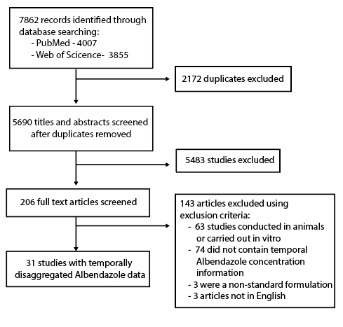

**Figure 1: PRISMA diagram illustrating the systematic review workflow.** Web of Science and PubMed were searched on 4th July 2019 using the keywords albendazole AND (treatment* OR dose* OR pharma* OR “half-life” OR “half life”). This produced a total of 5690 results after duplicate removal, of which 206 were retained for full text screening. 143 of the retained articles were subsequently excluded based on pre-defined exclusion criteria, yielding 31 studies containing temporally disaggregated data on Albendazole blood concentrations following treatment with a single dose; these 31 references contained 52 time series measuring Albendazole blood concentrations over time in different populations in total.

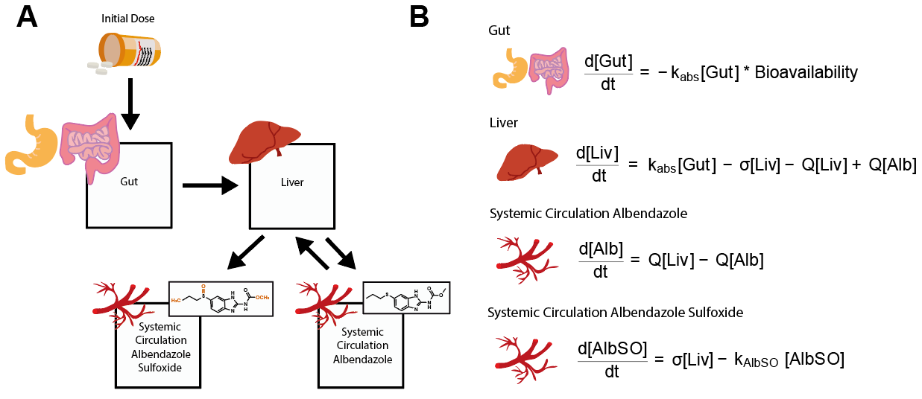

**Figure 2: Schematic of the model describing albendazole and albendazole sulfoxide dynamics and pharmacokinetics.** A compartmental model consisting of a series of linked ordinary differential equations (ODEs) was developed to simulate the pharmacokinetics of albendazole and its pharmacodynamically active metabolite, albendazole sulfoxide, in the blood following a single oral dose. **(A)** Model schematic, illustrating the model structure and the way in which the different compartments are linked. **(B)** The ordinary differential equations governing the pharmacokinetic model, representing the concentration of albendazole in the gut, the liver and systemic circulation, as well as the concentration of albendazole sulfoxide in systemic circulation.

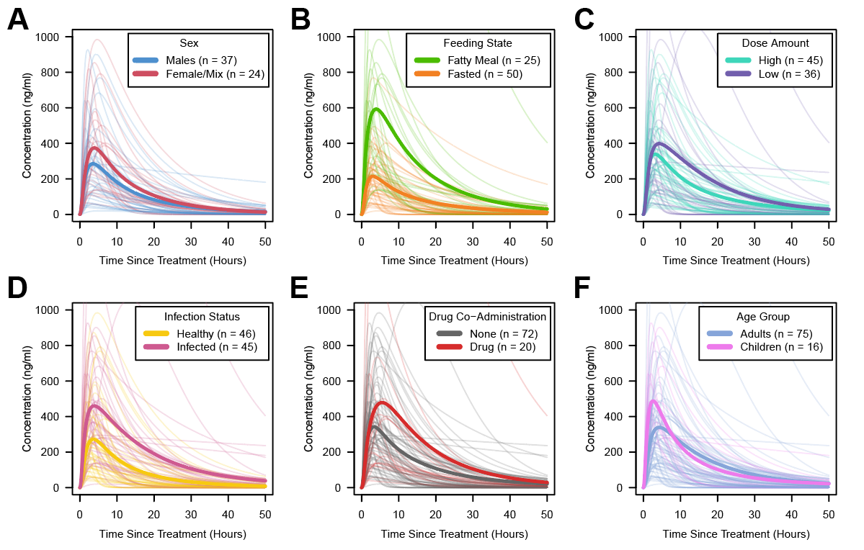

**Figure 3: Albendazole sulfoxide pharmaconkinetic variability, stratified by patient and dosage features.** In all panels displayed above, each pale line represents the fitted model output for a single time series, with the darker lines representing the average of the time series for a given category. Factors explored were **(A)** Sex; **(B)** Feeding Status (according to whether groups had received the single dose of Albendazole whether the dose was taken alongside a fatty meal or not); **(C)** Dose (with time-series crudely categorised into high/low strata based on whether the dose was higher than 400mg); **(D)** Infection Status (defined based on whether the patient population represented healthy individuals or those infected with parasitic infections necessitating treatment); **(E)** Co-Administered Drugs (i.e. whether albendazole was delivered alone or in tandem with other drugs); and **(F)** Age Group (defined based on whether the average age of the patients was below or above 16 years).

**Table 1: Regression Outputs Relating PK Properties to Characteristics.** Inferred parameters from the fitted pharmacokinetic curves, specifically Albendazole Bioavailability, Albendazole Sulfoxide half-life, CMax and AUC were regressed onto various patient population demographic and treatment metadata. The results of this multivariate regression are displayed below.

|  |  |  |  |  |  |  |  |  |
| --- | --- | --- | --- | --- | --- | --- | --- | --- |
|  | **Sex** | **Feeding Status** | **Dose** | **Drug Co-Administration** | **Age** | **Weight** | **Infection** | **R2** |
| **Bioavailability** | +8.43%  p = 0.24 | +18.2% p < 0.001 | -0.004%  p = 0.23 | -7.60%  p = 0.01 | +0.159%  p = 0.44 | -0.154%  p = 0.39 | -10.3%  p = 0.05 | 62 |
| **Half-Life** | -4.90  p = 0.39 | -2.76  p = 0.32 | -0.0006  p = 0.83 | -1.39  p = 0.52 | +0.34  p = 0.05 | -0.05  p = 0.73 | +1.22  p = 0.76 | 38 |
| **AUC** | +4068  p = 0.42 | +11800  p < 0.001 | +6.281  p = 0.02 | -4560  p = 0.02 | +384  p = 0.11 | -68.0  p = 0.59 | -7900  p = 0.59 | 62 |
| **C­­Max** | +222  p = 0.36 | +641  p < 0.001 | +0.401  p < 0.01 | -273  p < 0.01 | +9.92  p = 0.16 | -3.71  p = 0.54 | -363  p = 0.04 | 70 |

**Discussion**

Despite widespread usage, significant uncertainty surrounds the pharmacokinetics of the drug Albendazole, in particular the drivers and determinants of the variation observed in individuals receiving treatment. Whilst previous studies have explored individual factors contributing to this variation, a systematic and multi-variate exploration of these remained outstanding. This is despite the utility that a better understanding would likely have in enabling treatment to be optimised to the patient populations receiving it. Utilising a systematic review in conjunction with a pharmacokinetic modelling approach, we synthesise a wide array of the literature surrounding Albendazole’s pharmacokinetics. Our results yield new insight into the drivers of the observed variation between individuals and populations with respect to the pharmacokinetics of Albendazole and Albendazole Sulfoxide and reveal the pronounced impact of a number of factors on different pharmacokinetic parameters.

In particular, our multivariate analyses highlighted the importance of fatty meal consumption, dose, age and infection status on Albendazole’s pharmacokinetics. Importantly, these results are a systematically observed across multiple different studies.

Whilst a small number of studies have previously examined these factors individually17,23–25,.

Additionally, our univariate analyses suggested a role for sex in affecting various pharmacokinetic characteristics of Albendazole – whilst these were not significant in the multivariate analyses, previous results have indicated a role for sex in shaping the pharmacokinetic profile of Albendazole and Albendazole Sulfoxide13. Further work is required to clarify this relationship further, but important to note is the diminished sample size available for analysis with the multivariate analyses compared to the univariate analyses (36 time series compared to 55), something that likely limited our statistical power to detect differences. Our results also indicated that different factors impact different pharmacokinetic properties of Albendazole and Albendazole Sulfoxide – for example, whilst receipt of a fatty meal was associated with increases to Bioavailability, AUC and CMax­­, Age was significantly associated with Albendazole Sulfoxide half-life. These results reveal a pattern whereby different factors differentially influence and shape different aspects of Albendazole Sulfoxide’s pharmacokinetic profile, to generate the extensive observed variation.

Another important result arising from the work presented here has been the identification of substantial knowledge gaps surrounding the populations being studied. Our results revealed a pronounced absence of studies carried out in children - only 5 of the 55 time series identified as part of the systematic review had been carried out in children under 16 years old. This is despite the widespread usage of Albendazole in infant populations as part of programmatic mass drug administration-based strategies, and despite the identification here of a significant effect of age on Albendazole’s pharmacokinetic profile. Similarly, there was a substantial bias towards male populations observed in the studies identified here: on average, studies consisted of 78% males and only 22% females, with 23 time series belonging to male-only populations, and only a single study carried out in an exclusively female population. Other areas requiring attention include drug-interactions and parasitic infections. Although data constraints precluded fully disaggregating the data, numerous interactions between Albendazole and drugs such as cimetidine15, azithromycin26 and various anti-epileptic drugs27 have been identified in the literature and an overall effect was suggested here through our analyses. Our analyses also revealed the impact of parasitic infection on Albendazole’s pharmacokinetics. This is problematic given the key groups receiving Albendazole will receive it precisely because they are infected with parasites: despite this, the majority of studies (35 of 54 where infection status was determined) were carried out in healthy populations; populations whose pharmacokinetic profiles are perhaps unrepresentative of those that might occur in infected, non-healthy populations.

There are a number of limitations to the analyses presented here. Firstly, and perhaps most notably, because of constraints pertaining to the data available in the literature, which typically presented pharmacokinetic profiles as the average of a population of patients, we were unable to work with individual data, instead, having to work with aggregated population level data. This constraint limits the statistical power of our analyses to characterise the effects of individual drivers of pharmacokinetic variability. One notable example of this is Sex – due to the lack of individual data, we were unable to explore the exact influence of Sex, and instead had to utilise population level proxies (specifically here, the ratio of males:females in the study). Despite these limitations however, the collated metadata from each study on the patient populations receiving treatment allowed us to assess and explore a wide array of factors, either directly (in the case of factors that were homogeneous across patient groups, such as fasted/fatty meal status) or indirectly (through the use of population-level proxies for age, sex amd weight).

In addition to these constraints posed by population-level data, also important to note is that the results presented here pertain to treatment with a single dose of albendazole. Whilst this holds programmatic relevance given usage of mass drug administration of albendazole to treat communities for soil-transmitted helminths28 and lymphatic filariasis29 amongst others, it is important to note that the use of Albendazole in dedicated clinical settings for diseases such as cysticercosis and echinococcosis typically utilises treatment regimen consisting of multiple doses delivered over multiple days. Previous results have indicated that Albendazole appears to induce its own metabolism through induction of key enzymes in the liver19, and that multiple doses given over sequential days can lead to changes in pharmacokinetic properties over the course of multiple dose regimen; specifically, reductions in maximum blood concentrations of Albendazole Sulfoxide reached30. However, the magnitude of this effect and the frequency of dosing required to elicit pharmacologically relevant reductions in blood concentrations remains far from clear and has, to date, been addressed in only a limited number of studies. Exploration of this phenomenon and its consequences for anthelmintic treatment regimen using multiple doses of the drug would require both further clinical research and an extension of the mathematical model developed here, and likely represents an instructive avenue of future investigation. Similarly, extensions of the model to include infrequent but reported pharmacokinetic phenomena associated with Albendazole treatment, such as biphasic pharmacokinetic profiles (thought possibly to be a product of inter-individual variation in frequency of gastric emptying and other related characteristics31), would also likely provide new insight.

Overall however, and despite these limitations, our work provides insight into the factors contributing to and driving the variation observed in Albendazole’s pharmacokinetics. Importantly, it suggests ways in which the delivery of Albendazole in programmatic contexts might be pharmacokinetically optimised to maximise the impact of the drug’s distribution. Given the increasing frequency with which Albendazole is being utilised as part of community-based programmes aimed at controlling a wide array of parasitic infections, this increased understanding will hopefully hold important public health relevance.

**References**

1. Carpio, A. *et al.* Effects of albendazole treatment on neurocysticercosis: A randomised controlled trial. *J. Neurol. Neurosurg. Psychiatry* **79**, 1050–1055 (2008).

2. Teggi, A., Lastilla, M. G. & De Rosa, F. Therapy of human hydatid disease with mebendazole and albendazole. *Antimicrob. Agents Chemother.* **37**, 1679–1684 (1993).

3. Vlaminck, J. *et al.* Therapeutic efficacy of albendazole against soil-transmitted helminthiasis in children measured by five diagnostic methods. *PLoS Negl. Trop. Dis.* **13**, e0007471 (2019).

4. Simonsen, P. E. *et al.* Lymphatic Filariasis Control in Tanzania: Effect of Repeated Mass Drug Administration with Ivermectin and Albendazole on Infection and Transmission. *PLoS Negl. Trop. Dis.* **4**, e696 (2010).

5. Macfarlane, C. L., Budhathoki, S. S., Johnson, S., Richardson, M. & Garner, P. Albendazole alone or in combination with microfilaricidal drugs for lymphatic filariasis. *Cochrane Database Syst. Rev.* **2019**, (2019).

6. Kamgno, J. *et al.* A Test-and-Not-Treat Strategy for Onchocerciasis in *Loa loa* –Endemic Areas. *N. Engl. J. Med.* **377**, 2044–2052 (2017).

7. Jung-Cook, H. Pharmacokinetic variability of anthelmintics: implications for the treatment of neurocysticercosis. *Expert Rev. Clin. Pharmacol.* **5**, 21–30 (2012).

8. Del Brutto, O. H. Albendazole therapy for subarachnoid cysticerci: Clinical and neuroimaging analysis of 17 patients. *J. Neurol. Neurosurg. Psychiatry* **62**, 659–661 (1997).

9. García, H. H. *et al.* Current consensus guidelines for treatment of neurocysticercosis. *Clinical Microbiology Reviews* **15**, 747–756 (2002).

10. Jung-Cook, H. Pharmacokinetic variability of anthelmintics: Implications for the treatment of neurocysticercosis. *Expert Review of Clinical Pharmacology* **5**, 21–30 (2012).

11. Humphries, D. *et al.* Effectiveness of albendazole for hookworm varies widely by community and correlates with nutritional factors: A cross-sectional study of school-age children in Ghana. *Am. J. Trop. Med. Hyg.* **96**, 347–354 (2017).

12. Mrus, J., Baeten, B., Engelen, M. & Silber, S. A. Efficacy of single-dose 500 mg mebendazole in soil-transmitted helminth infections: a review. *J. Helminthol.* **92**, 269–278 (2018).

13. Mirfazaelian, A., Dadashzadeh, S. & Rouini, M. R. Effect of gender in the disposition of albendazole metabolites in humans. *Eur. J. Clin. Pharmacol.* **58**, 403–408 (2002).

14. Awadzi, K. *et al.* The co-administration of ivermectin and albendazole safety, pharmacokinetics and efficacy against Onchocerca volvulus. *Ann. Trop. Med. Parasitol.* **97**, 165–178 (2003).

15. Schipper, H. G. *et al.* Effect of dose increase or cimetidine co-administration on albendazole bioavailability. *Am. J. Trop. Med. Hyg.* **63**, 270–273 (2000).

16. Lange, H., Eggers, R. & Bircher, J. Increased systemic availability of albendazole when taken with a fatty meal. *Eur. J. Clin. Pharmacol.* **34**, 315–317 (1988).

17. Mares, S. S., Jung, C. H., Lopez, A. T. & Gonzalez-Esquivel, D. F. Influence of a Mexican diet on the bioavailability of albendazole. *BASIC Clin. Pharmacol. Toxicol.* **97**, 122–124 (2005).

18. Edi, C. *et al.* Pharmacokinetics, safety, and efficacy of a single co-administered dose of diethylcarbamazine, albendazole and ivermectin in adults with and without Wuchereria bancrofti infection in Côte d’Ivoire. *PLoS Negl. Trop. Dis.* **13**, e0007325 (2019).

19. Steiger, U., Cotting, J. & Reichen, J. Albendazole treatment of echinococcosis in humans: Effects on microsomal metabolism and drug tolerance. *Clin. Pharmacol. Ther.* **47**, 347–353 (1990).

20. Nagy, J. *et al.* Effect of grapefruit juice or cimetidine coadministration on albendazole bioavailability. *Am. J. Trop. Med. Hyg.* **66**, 260–263 (2002).

21. Jung, H., Medina, L., Garcia, L., Fuentes, I. & Moreno-Esparza, R. Absorption studies of albendazole and some physicochemical properties of the drug and its metabolite albendazole sulphoxide. *J. Pharm. Pharmacol.* **50**, 43–48 (1998).

22. Lawrenz, A., Eglit, S. & Kroker, R. [The metabolism of albendazole in the isolated perfused intestine of rats]. *Dtsch. Tierarztl. Wochenschr.* **99**, 416–8 (1992).

23. Jung, H. *et al.* Clinical pharmacokinetics of albendazole in children with neurocysticercosis. *Am. J. Ther.* **4**, 23–26 (1997).

24. Pengsaa, K. *et al.* Pharmacokinetic investigation of albendazole and praziquantel in Thai children infected with Giardia intestinalis. *Ann. Trop. Med. Parasitol.* **98**, 349–357 (2004).

25. Mirfazaelian, A., Rouini, M. R. & Dadashzadeh, S. Dose dependent pharmacokinetics of albendazole in human. *Biopharm. Drug Dispos.* **23**, 379–383 (2002).

26. Amsden, G. W., Gregory, T. B., Michalak, C. A., Glue, P. & Knirsch, C. A. Pharmacokinetics of azithromycin and the combination of ivermectin and albendazole when administered alone and concurrently in healthy volunteers. *Am. J. Trop. Med. Hyg.* **76**, 1153–1157 (2007).

27. Perucca, E. Clinically relevant drug interactions with antiepileptic drugs. *British Journal of Clinical Pharmacology* **61**, 246–255 (2006).

28. Echazú, A. *et al.* Albendazole and ivermectin for the control of soil-transmitted helminths in an area with high prevalence of Strongyloides stercoralis and hookworm in northwestern Argentina: A community-based pragmatic study. *PLoS Negl. Trop. Dis.* **11**, (2017).

29. Weil, G. J. *et al.* The safety of double- and triple-drug community mass drug administration for lymphatic filariasis: A multicenter, open-label, cluster-randomized study. *PLOS Med.* **16**, e1002839 (2019).

30. HOAKSEY, P. E. *et al.* RAPID AND SENSITIVE METHOD FOR THE DETERMINATION OF ALBENDAZOLE AND ALBENDAZOLE SULFOXIDE IN BIOLOGICAL-FLUIDS. *J. Chromatogr. Appl.* **566**, 244–249 (1991).

31. Davies, N. M., Takemoto, J. K., Brocks, D. R. & Yáñez, J. A. Multiple peaking phenomena in pharmacokinetic disposition. *Clinical Pharmacokinetics* **49**, 351–377 (2010).